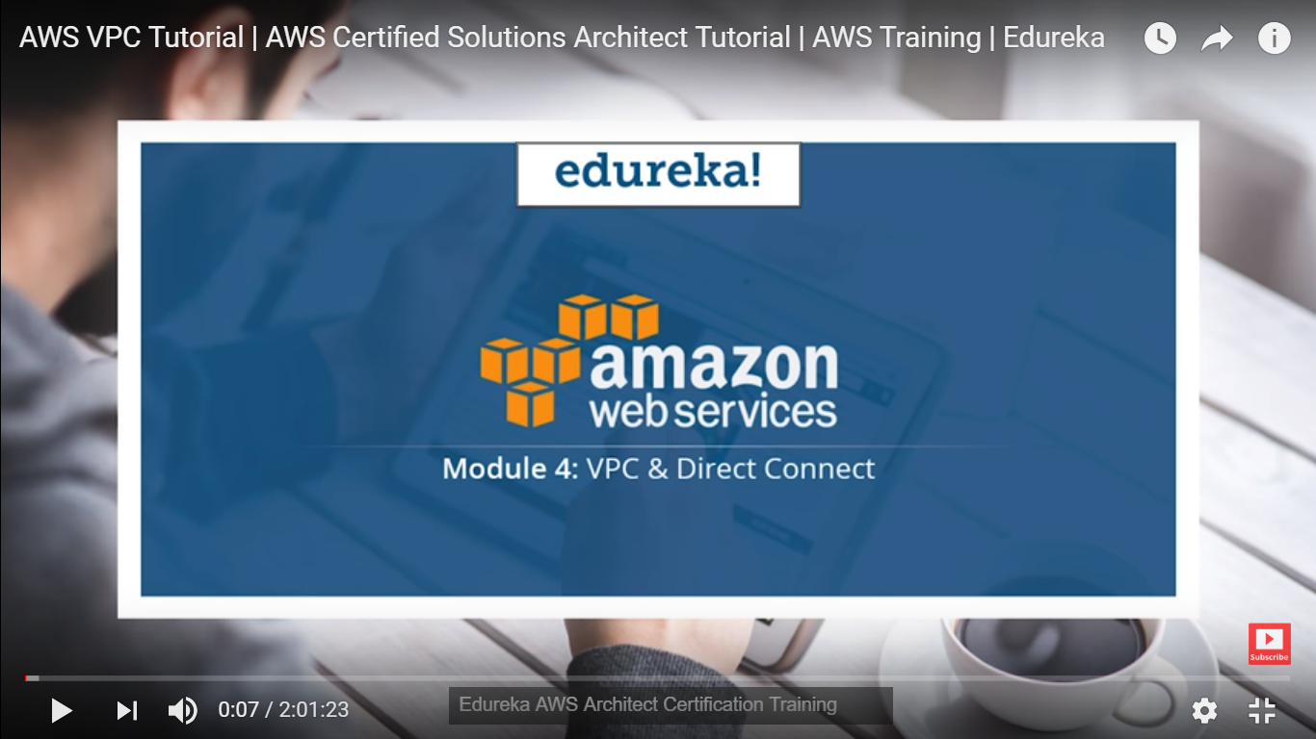

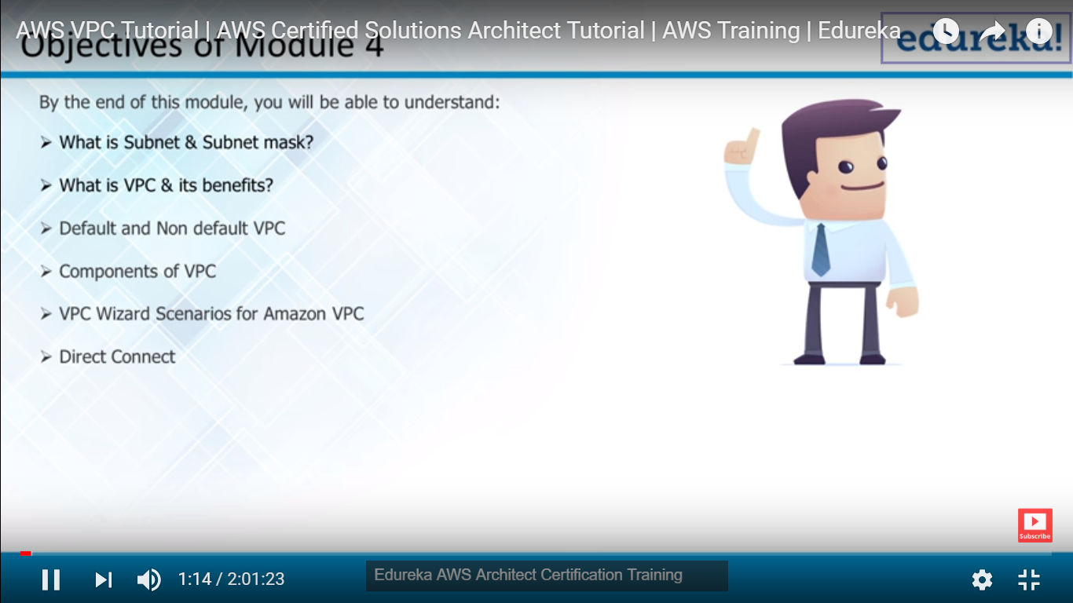

A subnetwork or **subnet** is a logical subdivision of an IP **network**

What is IP Address? IPv4 Vs IPv6?

IP address is address of your device, website(host)

We still using IPV4 although all IP’s are full but using NAT we are able to do that

Note : each device has its IP laptop, mobile, vehicle in future tracking a thief also can be possible to track we can provide each Ip to thief and we can track them.

Q: Why Does WhatIsMyIP.com Show a Different IP Address Than IPConfig?

The **IP address** shown on the What Is **My IP** home page is your **public IP address** also referred to as your external **IP**. ... However, if your computer connects to a router then the computer will most likely get an internal **IP address** like 192.168.1.100 and your router will get the external **IP address**

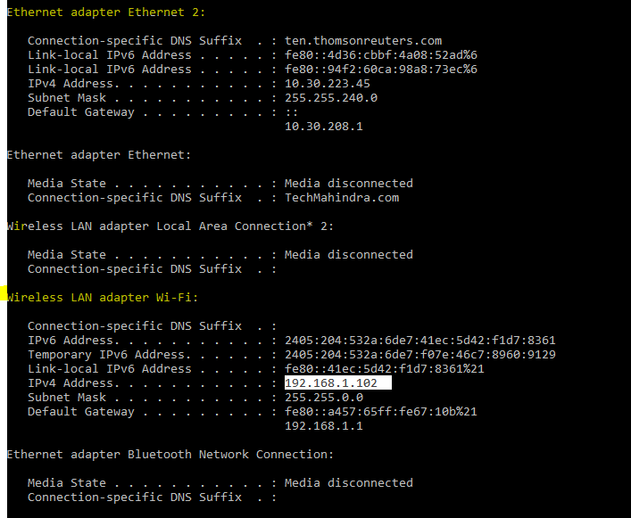

**IP for LAN and Ethernet**

**If you want to know IP address of your laptop**

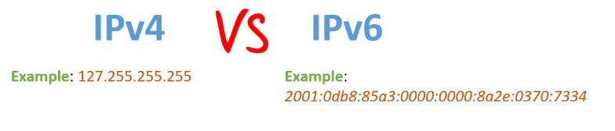

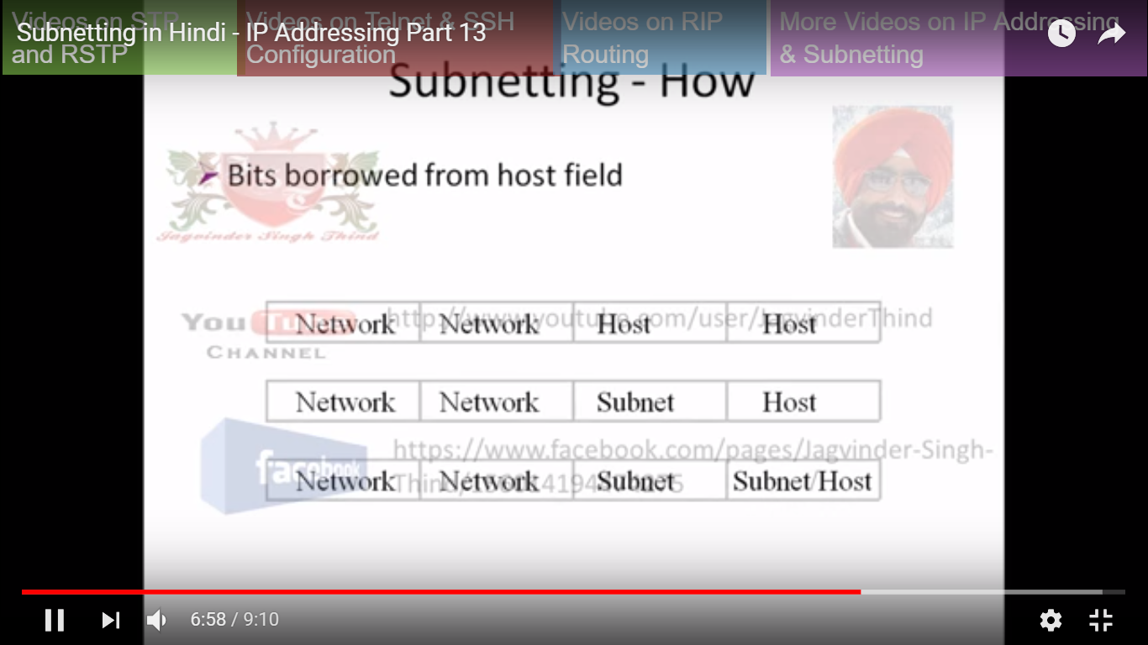

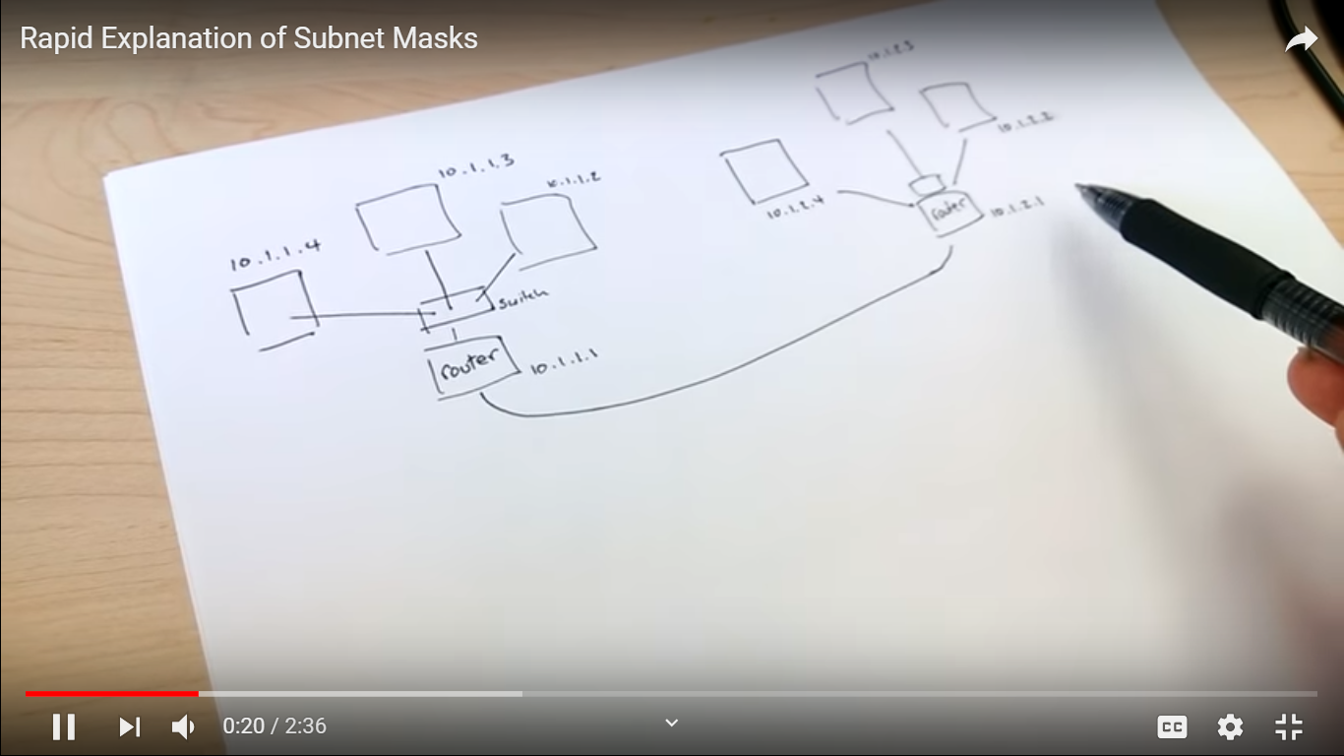

<https://www.youtube.com/watch?v=Deq9Dq-Kc-k> Read this for subnetting

A **netmask** is a [32-bit](https://www.computerhope.com/jargon/num/32bit.htm) mask used to divide an IP address into subnets and specify the network's available hosts. In a netmask, two [bits](https://www.computerhope.com/jargon/b/bit.htm) are always automatically assigned. For example, in 255.255.225.0, "0" is the assigned network address. In 255.255.255.255, "255" is the assigned [broadcast](https://www.computerhope.com/jargon/b/broadcas.htm) address. The 0 and 255 are always assigned and cannot be used.

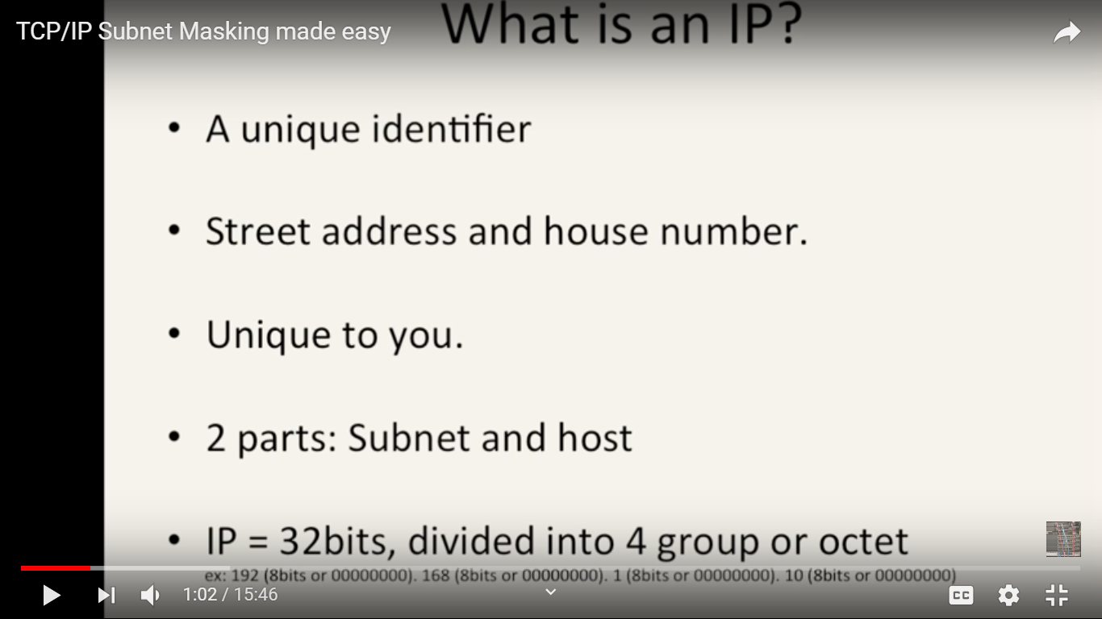

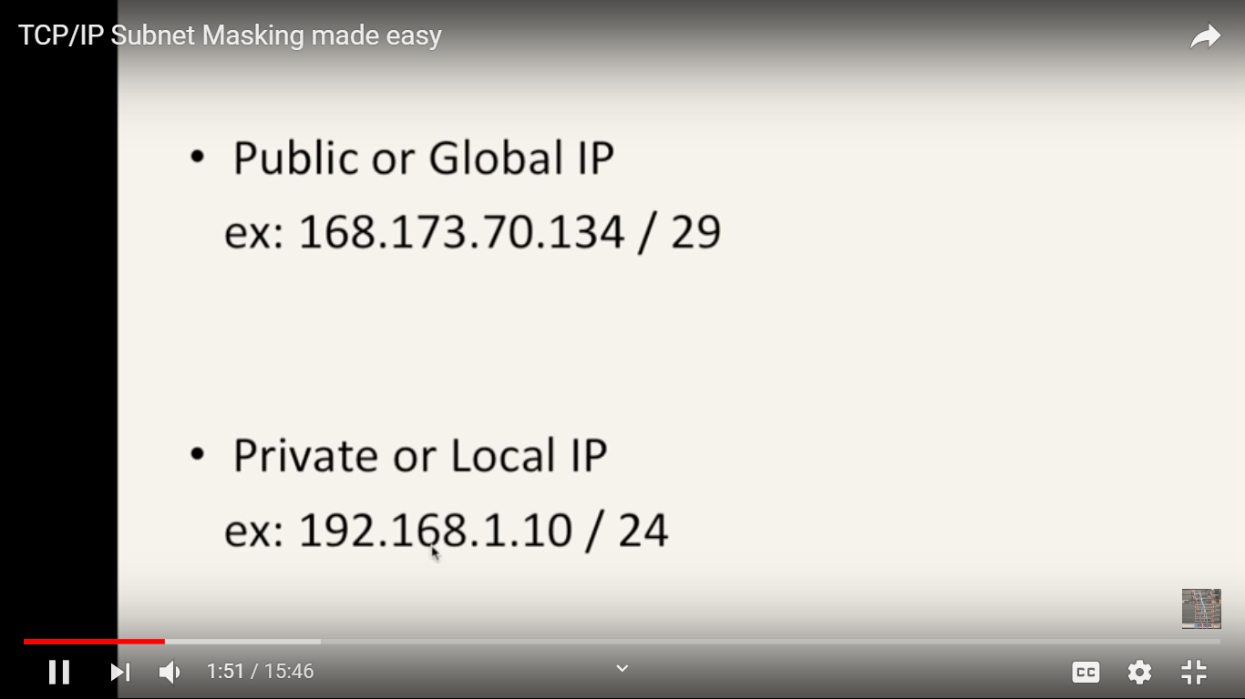

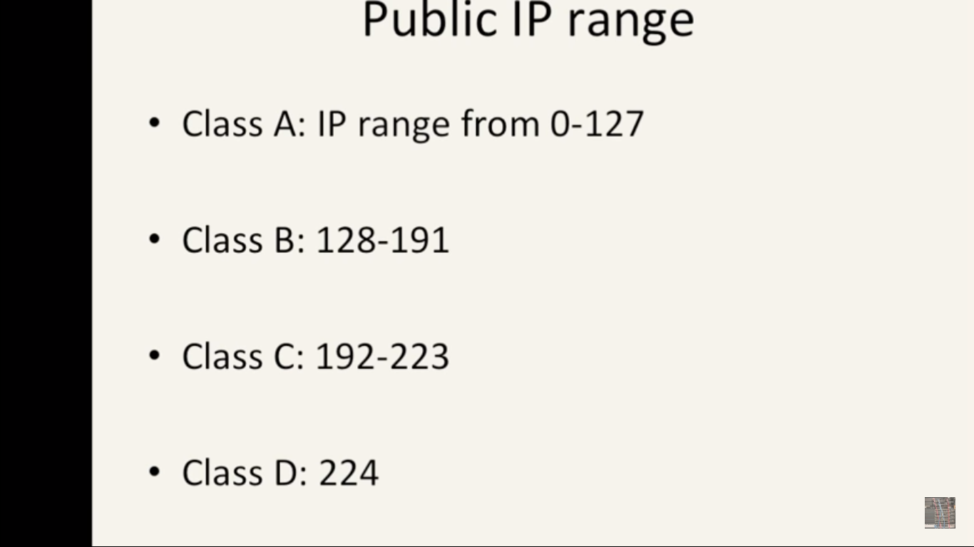

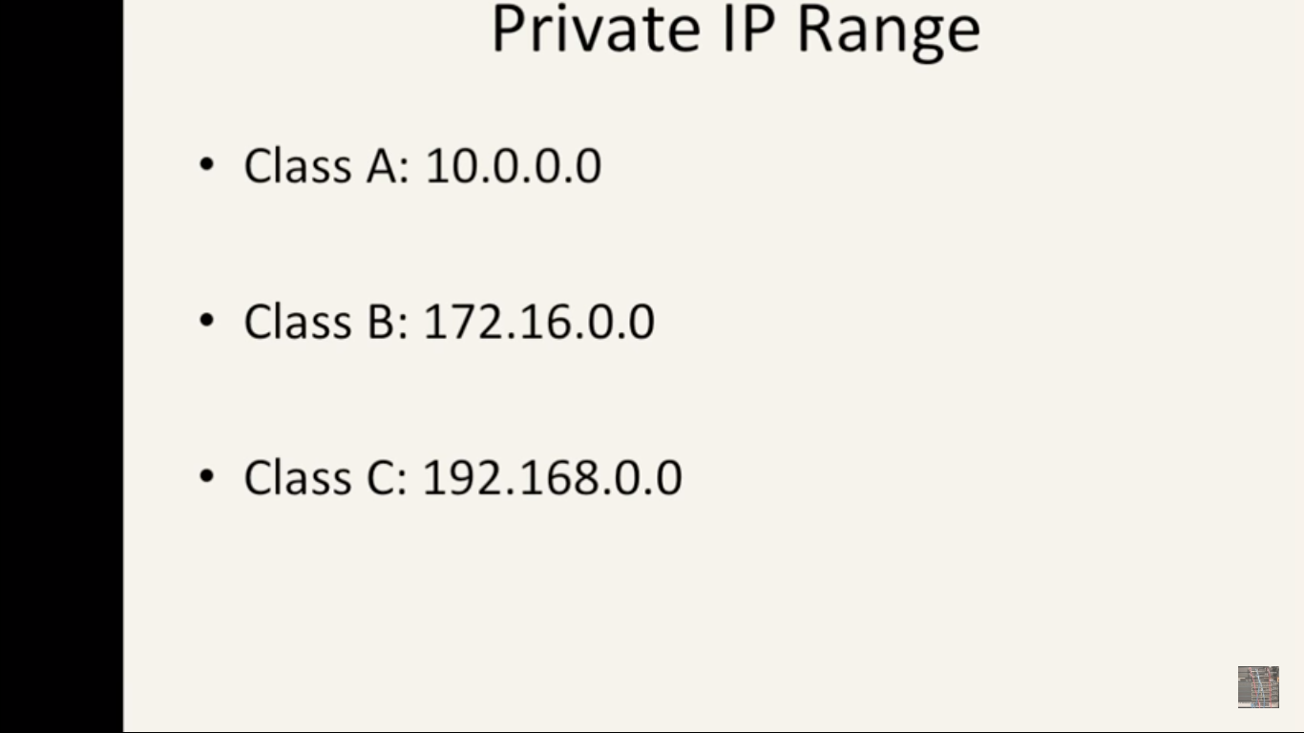

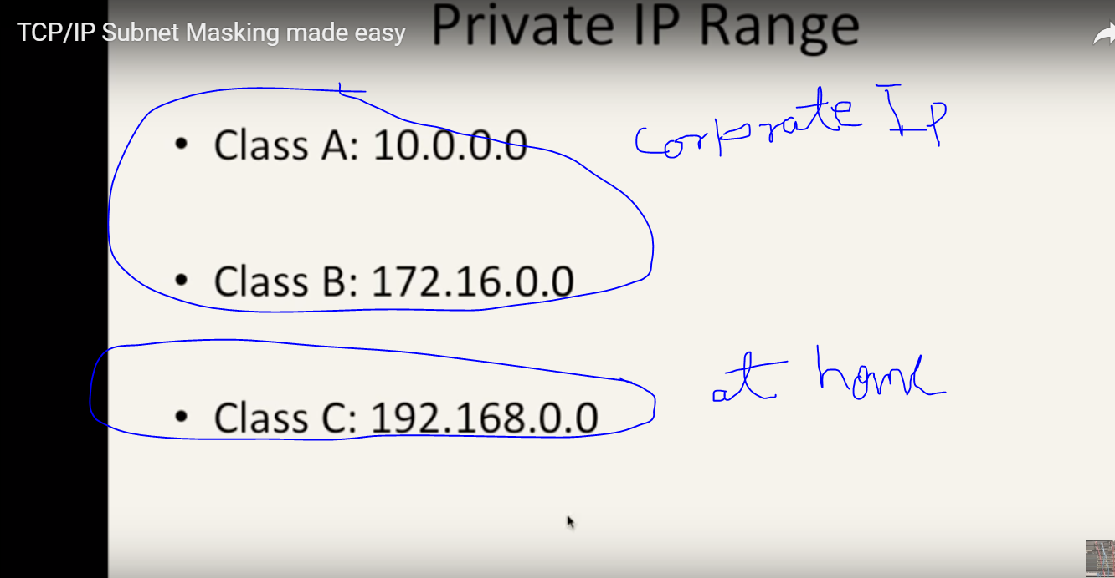

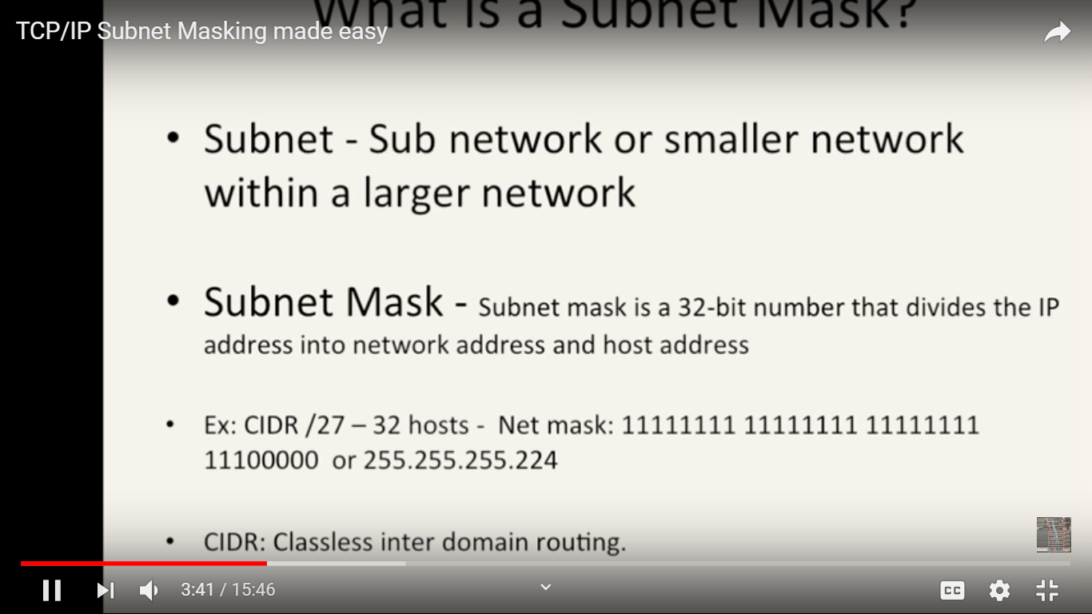

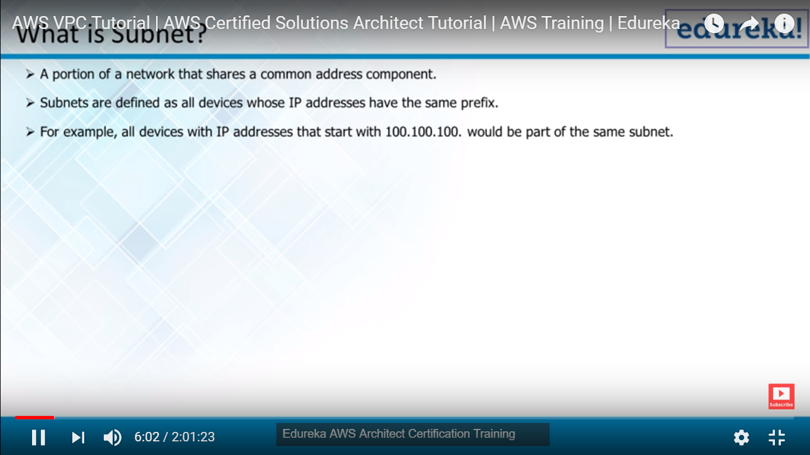

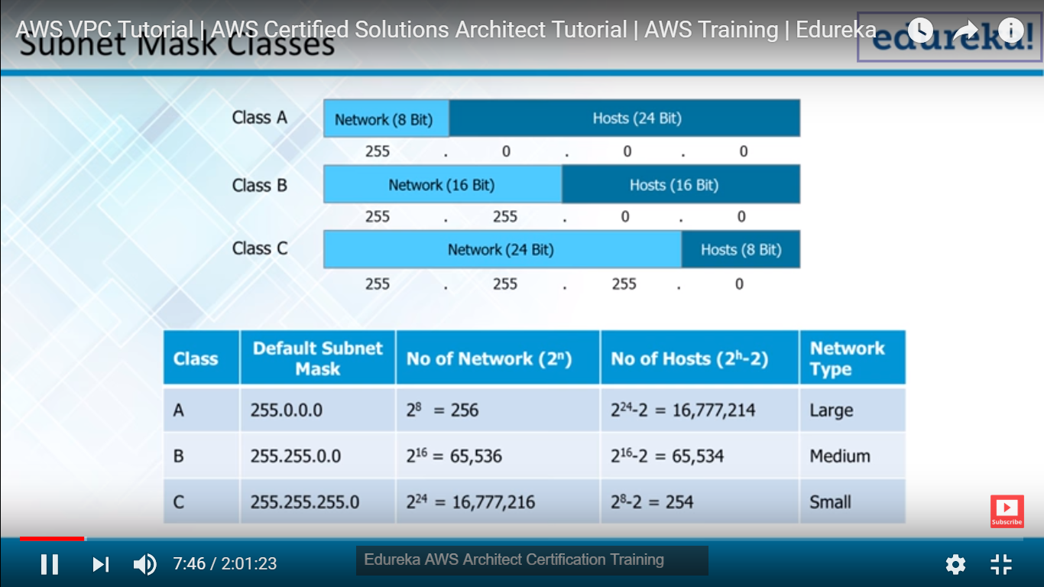

**CIDR WikiPedia:**

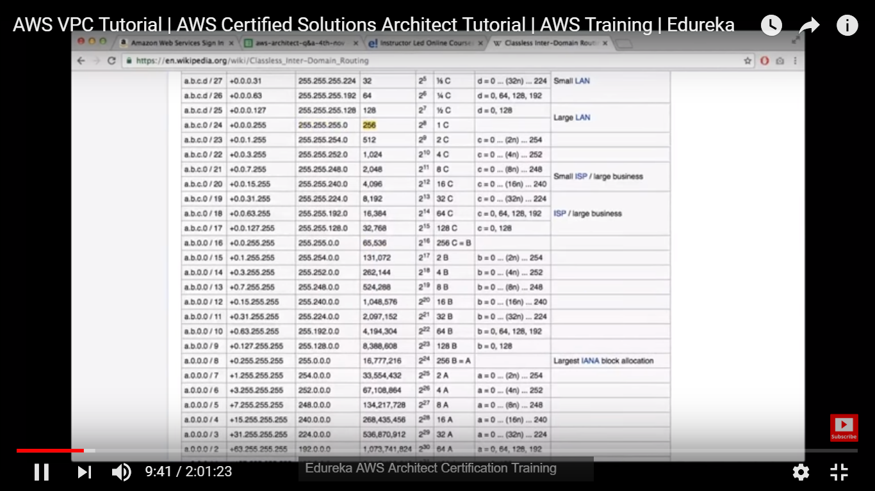

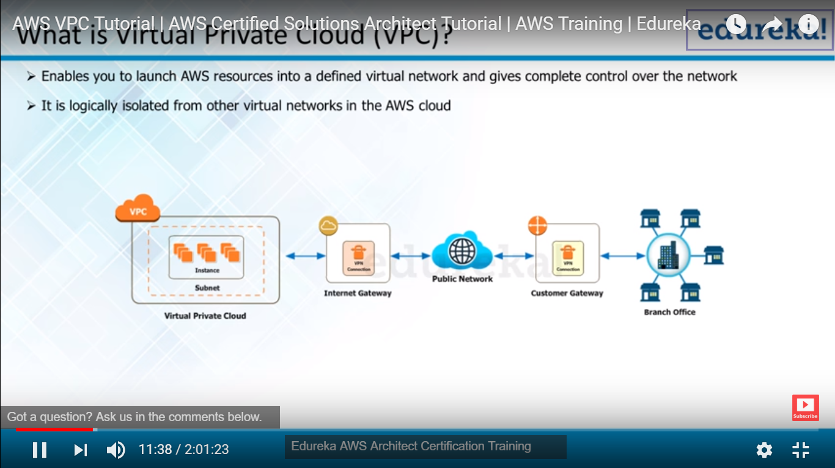

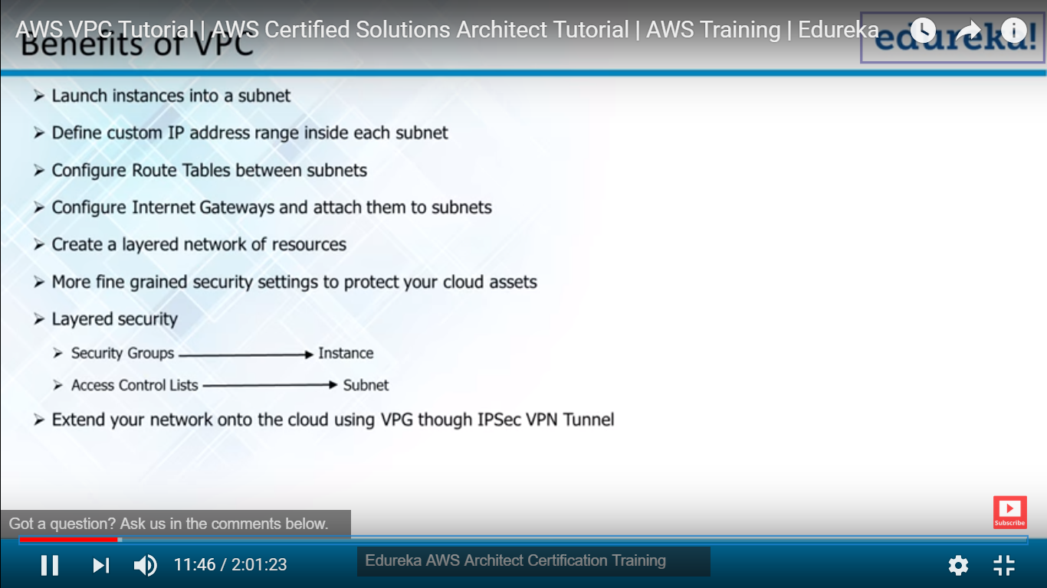

**Two firewall Layered Security is Security Group and Access Control lists**

**Default is Not meant for Production**

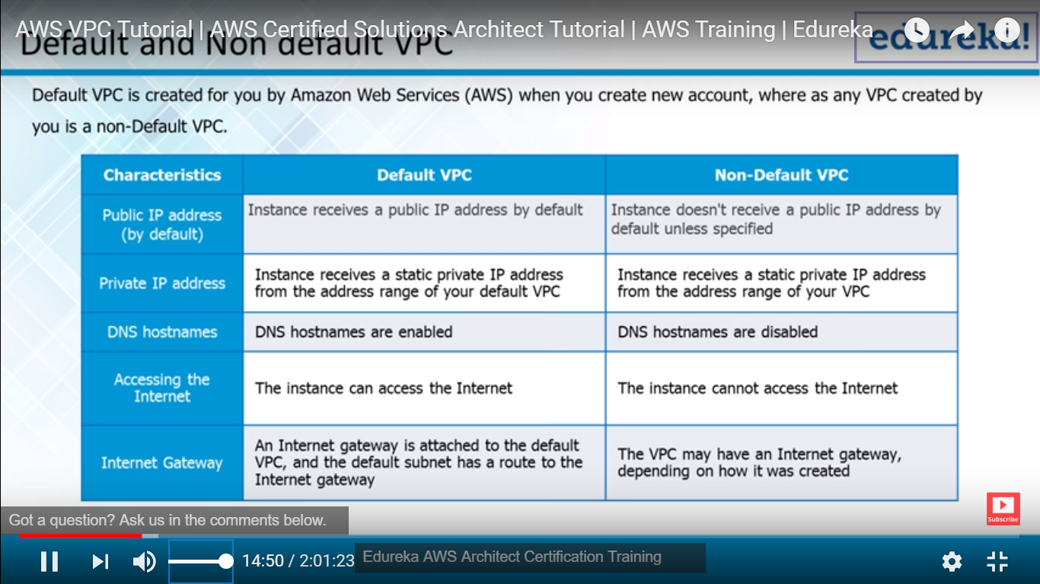

**Non-Default is very secure.**

**With in VPC we should have Security Group**

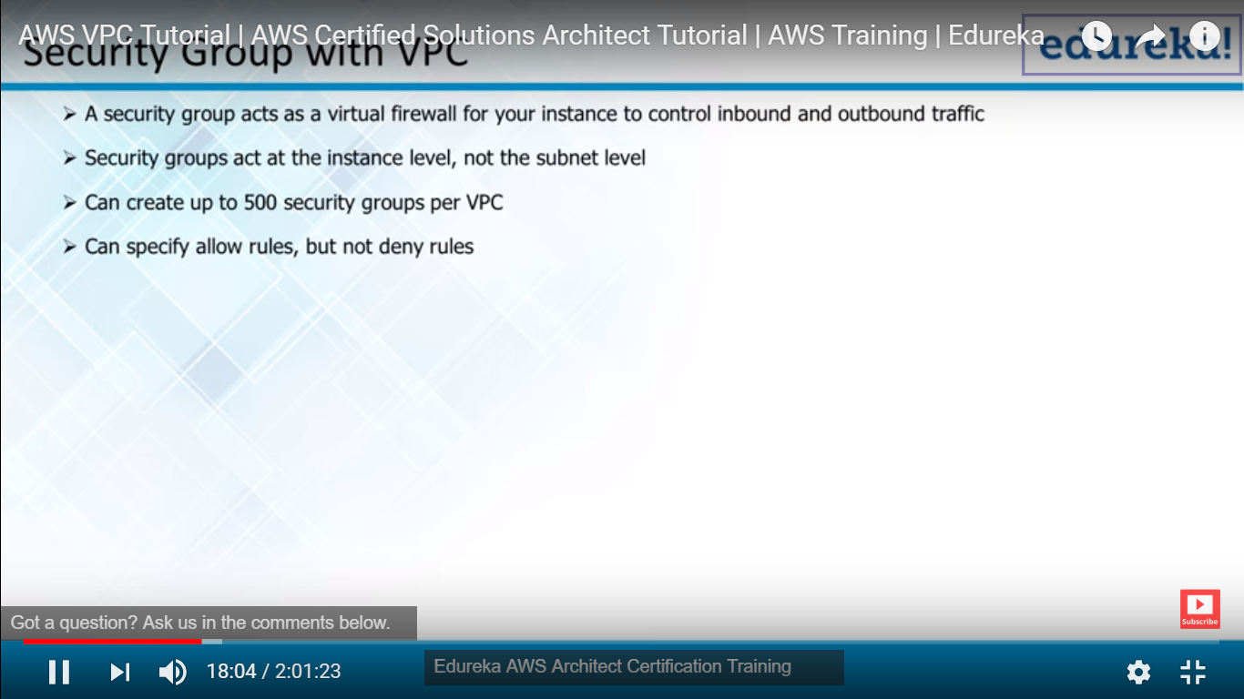

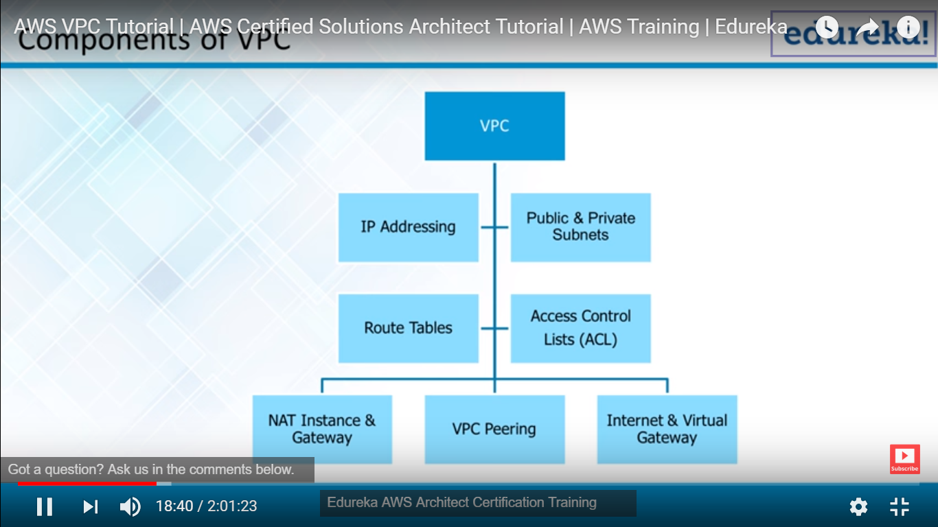

**Subnet ----|**

**Public Subnet:- U can use through internet**

**Private Subnet : U cant connect through internet, u can connect through VPN or indirectly**

**ACL is :- is Firewall at network level**

**Routing Table : How traffic flow with in the VPC and outside the VPC**

**Internet gateway : Use Subnet to make publically available, we can associate subnet and make traffic to and fro b/w VPC and outside**

**NAT Gateway : If u associate ur Private subnet to NAT u can use for private traffic communication this is only outbound Side .**

**Ex: If ur server is bound to be install s/w patches and download from source u can use this.**

**VPC : This meant for connection b/w VPN and VPC, We connect within VPC as well**

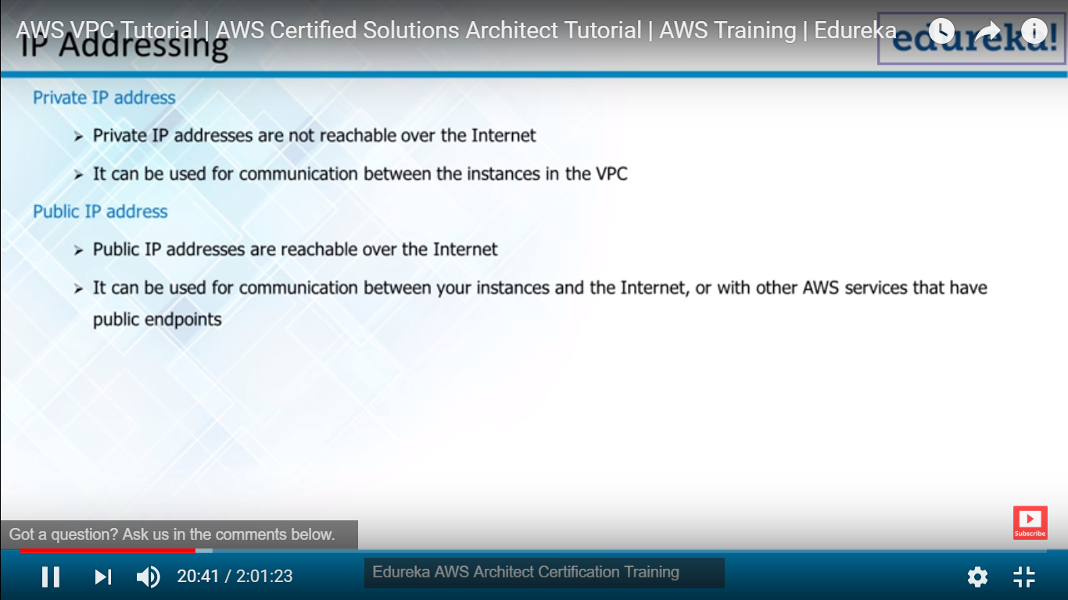

**Private Ip : We can’t access from internet its use internal communication b/w VPC**

**Public IP : We connect through internet mostly we are making server to be public**

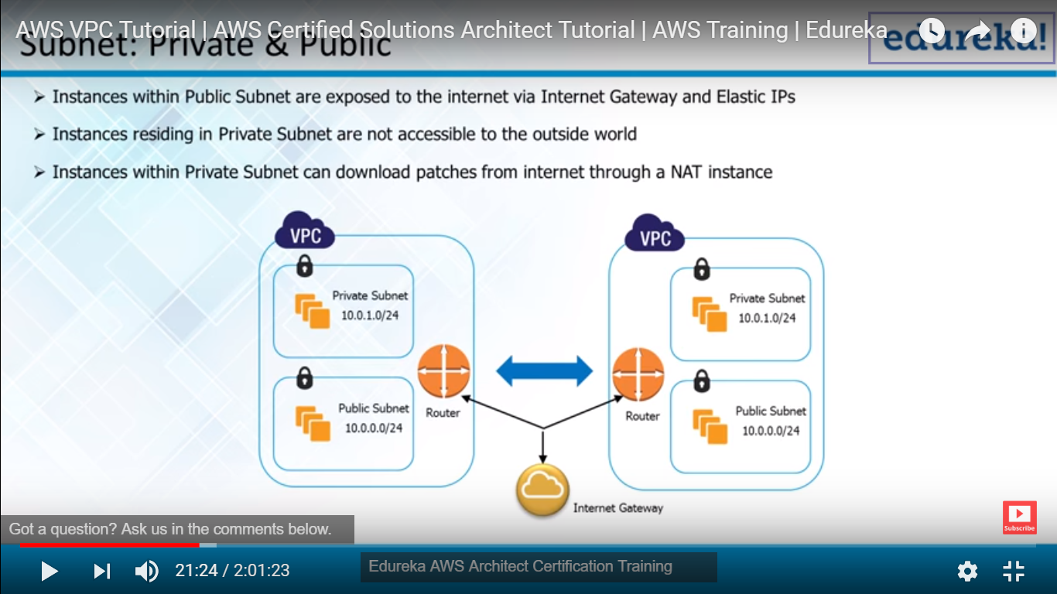



**Intenate Gatway : Determind to which one private subnet and which one is public**

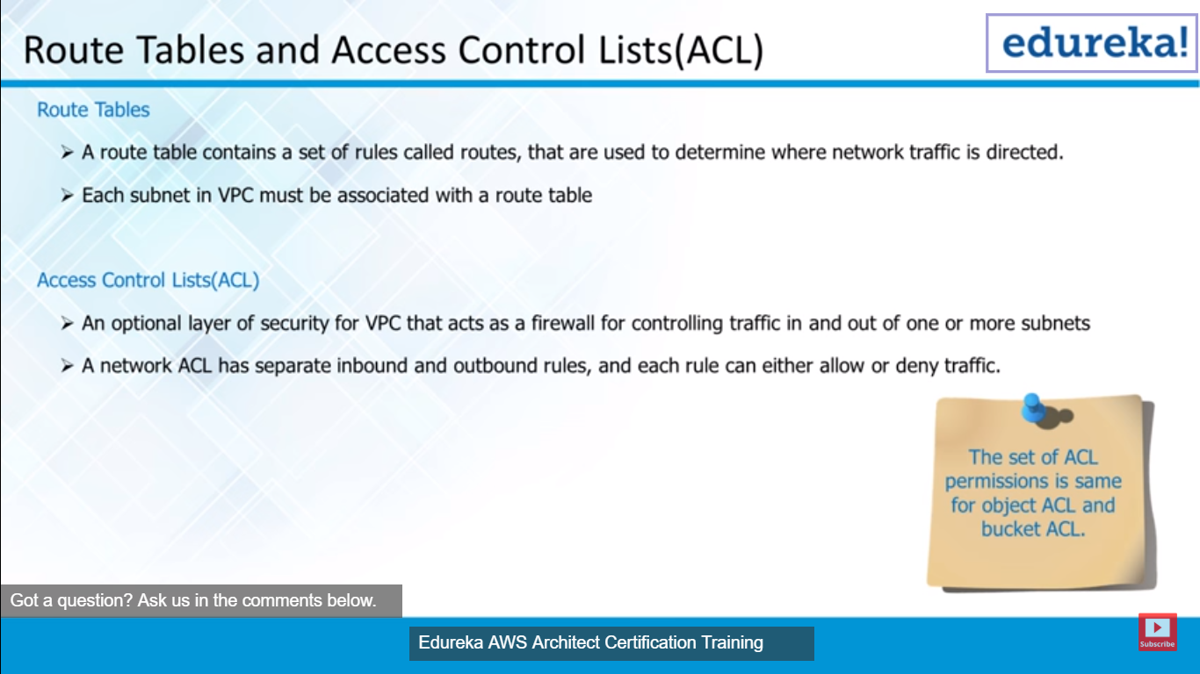

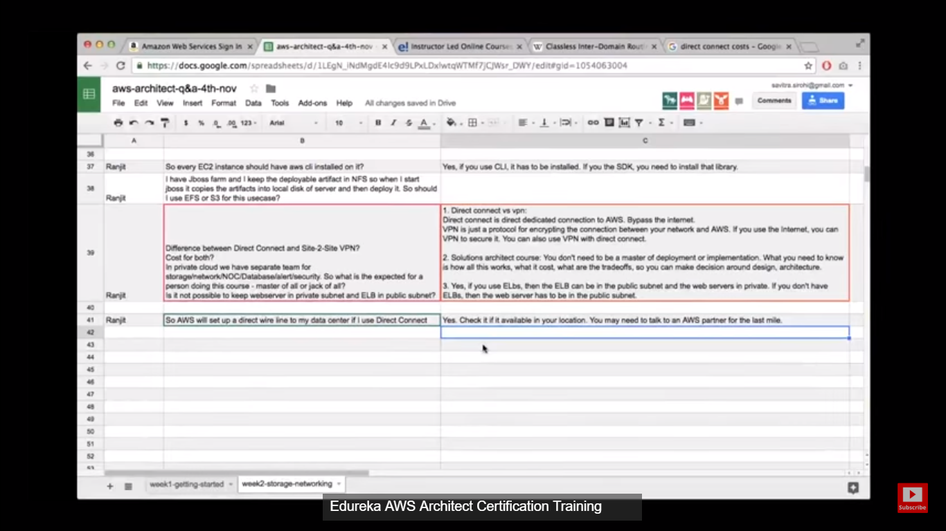

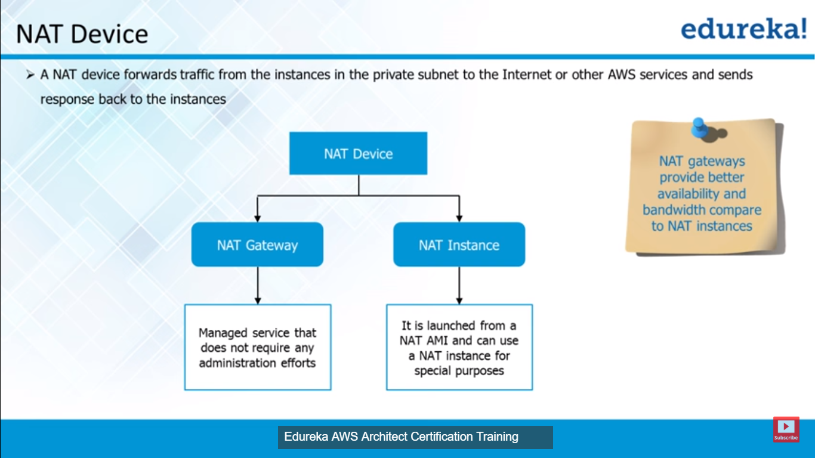

**NAT Is only bound to be for outbound traffic**

**Recommended to USE NAT gateway instead of Nat instance**

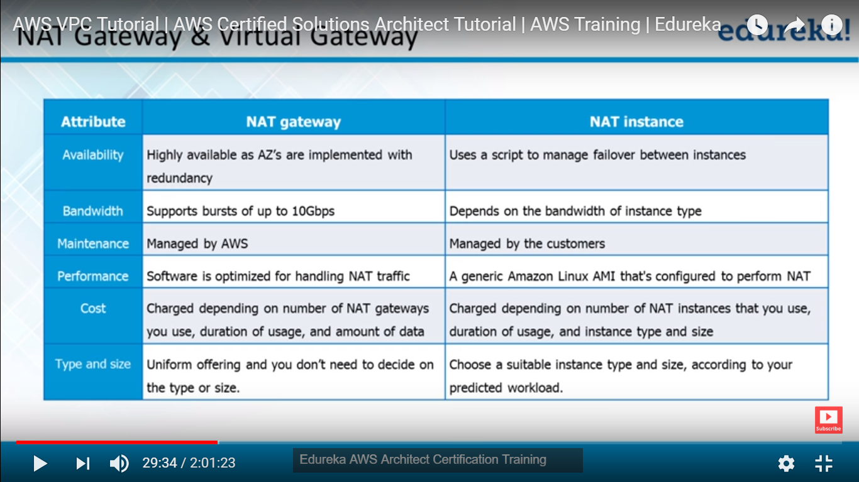

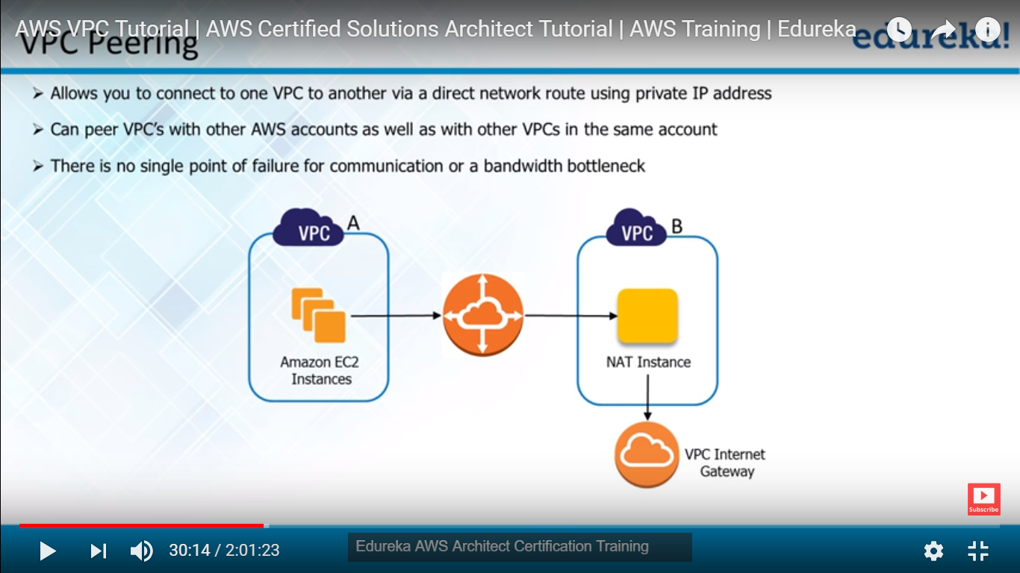

**Where we required VPC :**

**First these are private network u cant connect them even you know the Ip address of both how u can connect by doing peering**

**Ex : In your company there is Accounting department and Finance department Hr department(VPC of each department) these are different application and we want to talk to them by using peering them.**

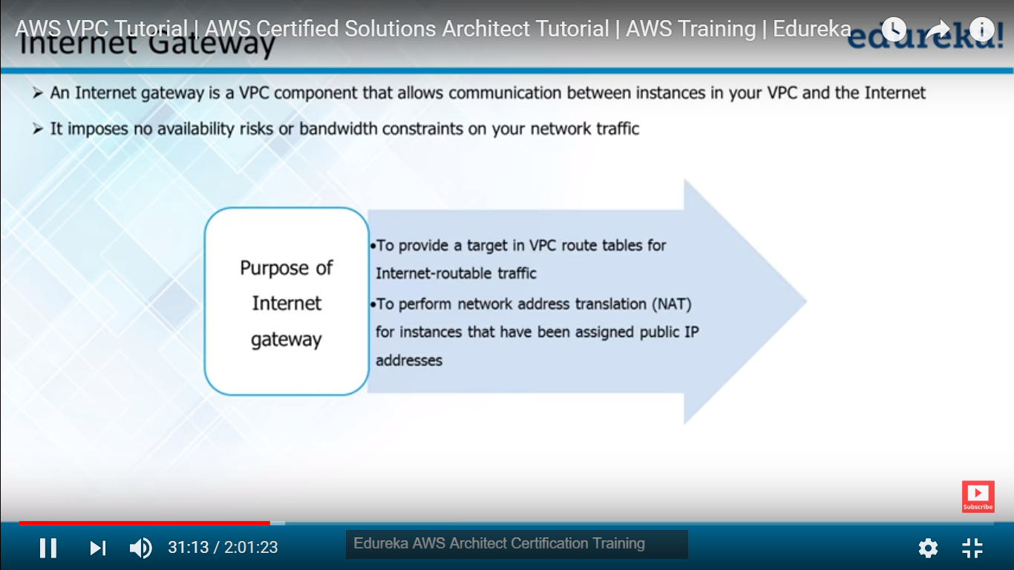

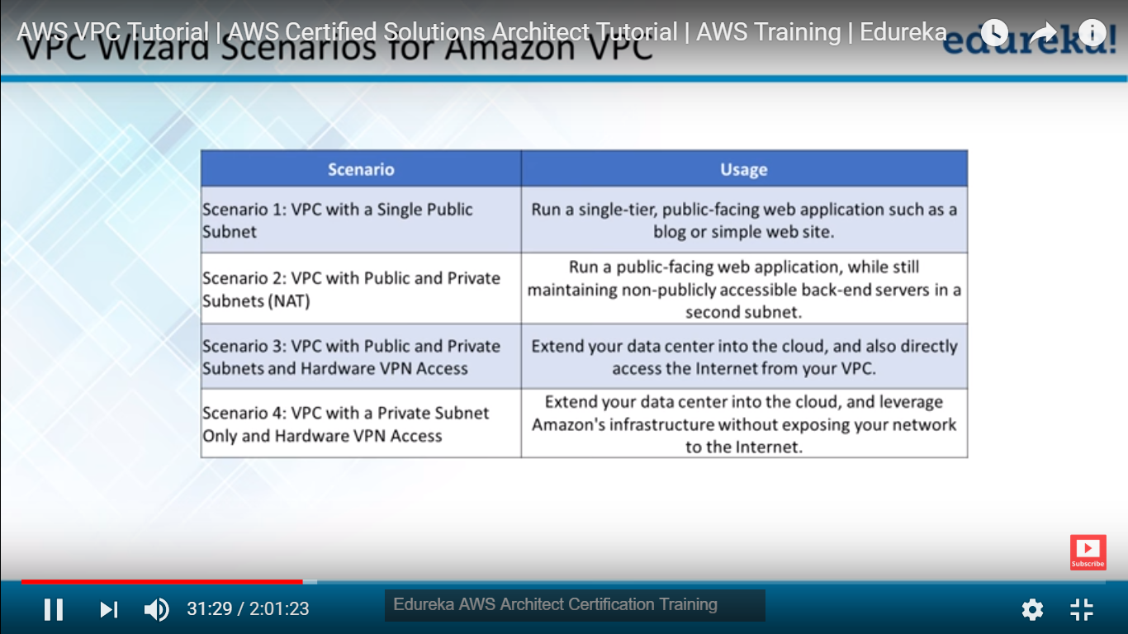

**Scenario 2: Public can be webserver and Private is Database**

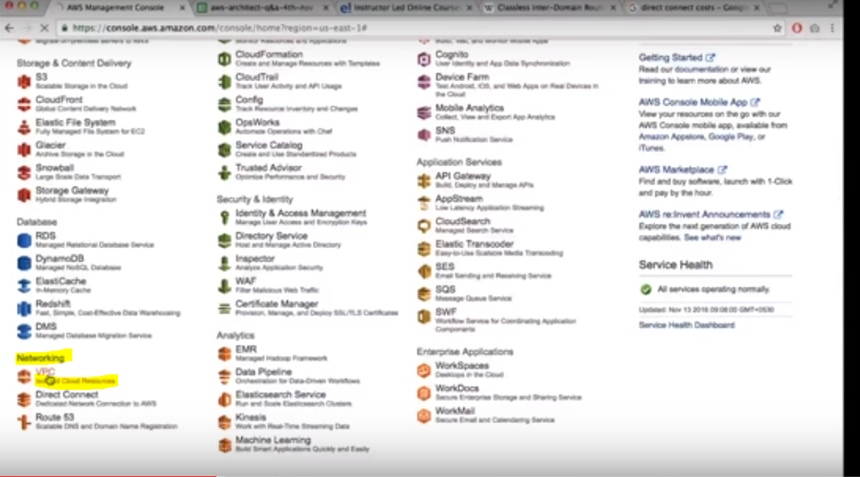

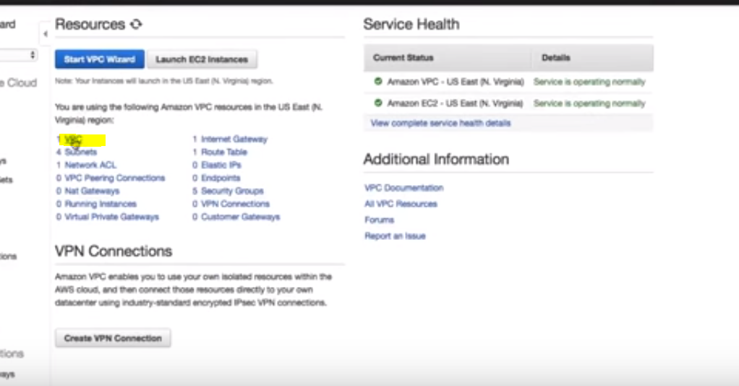

**Default VPC is there but it’s not more secure for your production**

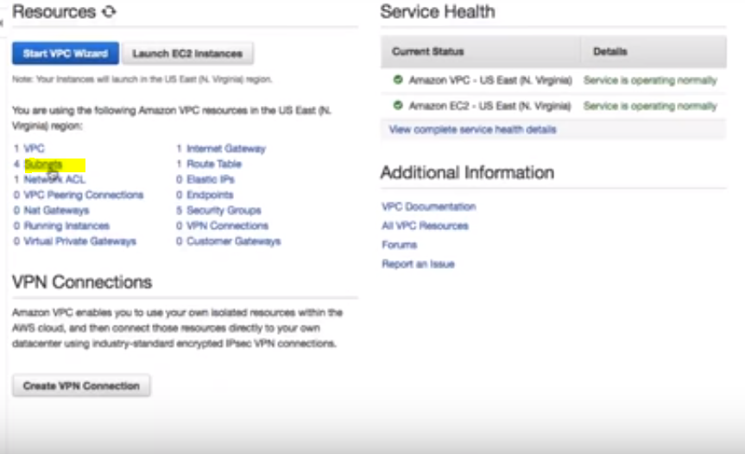

**VPC 1: - VPC can be only one region it cant expand more region**

**Subnet 4:- In each availably zone, Can be only one availability zone**

**-🡪Two factor authentication in account AWS(Read about this )**